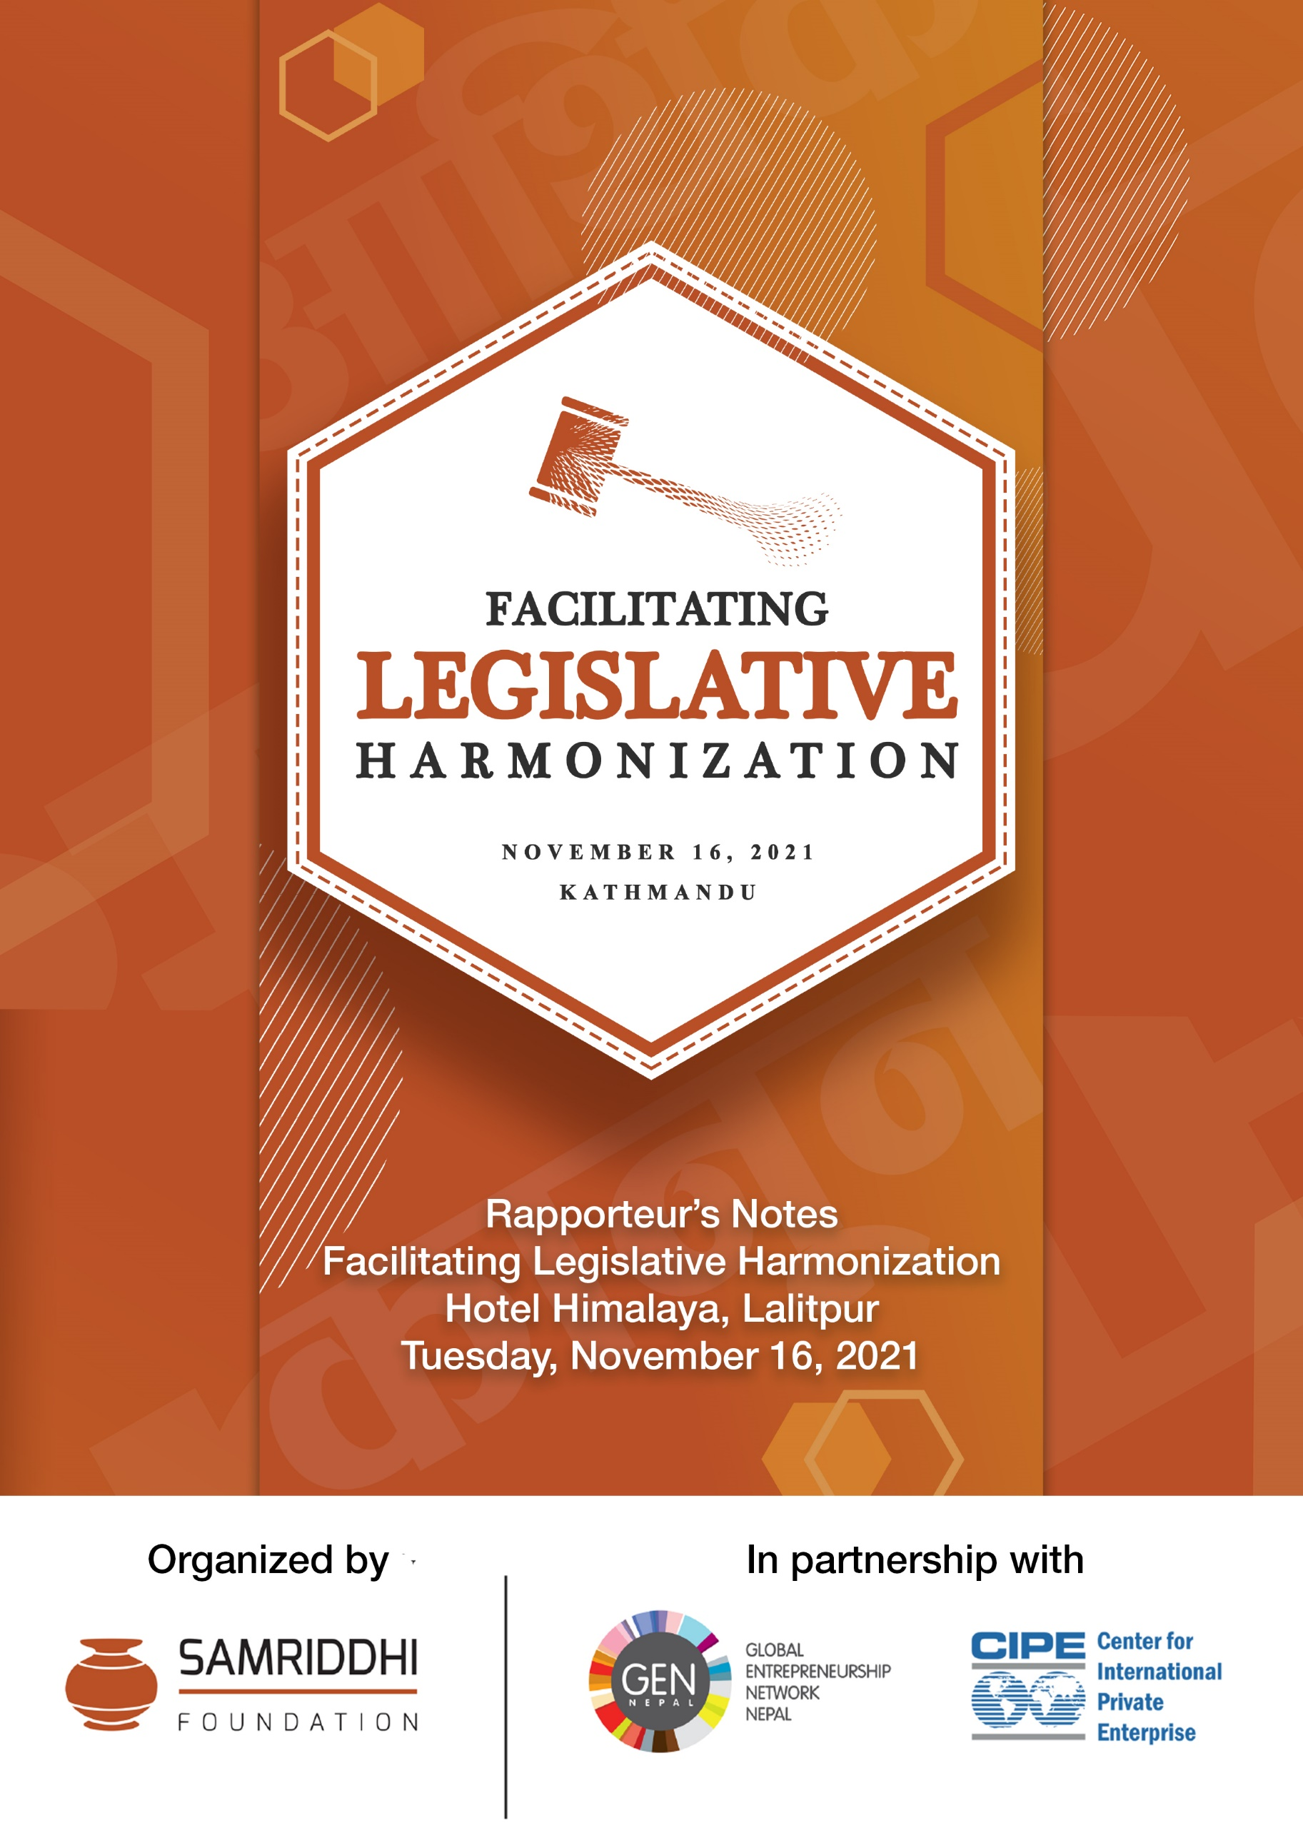

On Tuesday, November 16, Samriddhi Foundation launched the Legislation Repository - a website developed by Samriddhi that brings together all relevant information required for starting and operating a business and bringing in investment in Nepal. The launch was followed by a panel discussion on ‘Facilitating Legislative Harmonization’, featuring Mr. Narayan Prasad Sharma Duwadee, Joint Secretary of the Ministry of Industry, Commerce, and Supplies, Member Secretary Mr. Kewal Prasad Bhandari, National Planning Commission, Economist Dr. Chandan Sapkota, and Investment law expert Ms. Aayushi Koirala and was moderated by Adv. Semanta Dahal.

The panel discussion on “Facilitating Legislative Harmonization’ delved into finding possible alternatives that integrate the myriad policies and laws on regulation, monitoring and compliance and eventually reduce cost of starting and operating an enterprise or bringing in investment in Nepal.

What follows is the rapporteur’s notes on the proceedings of the discussion.

- Opening remarks by Akash Shestha

Samriddhi Foundation has been working with government agencies, multilateral agencies, and other private agencies. We have been actively working in areas of advocacy for policy reforms. Until the present, we have achieved considerable success in different policy-making.

The Idea of this current discussion is based on long relationships and findings that we have been conducting. As we talk about public sector development, the sheer volume of legislation makes it challenging for the private sector to catch up with it. Hence, to ease private enterprises and to ensure that right information is spread, we are launching this legislative repository to fill this void of legislative harmonization for existing and aspiring entrepreneurs. We still have a lot of areas to improve the current project, and we hope to improve with your valuable feedback.

The present launch and panel discussion is based on the findings of our previous discourse on Integration of Economic Legislations. And, we are certain to be nourished with lengthy and fruitful discussion as we are accompanied by a rich panel today.

Our past observations demonstrate that in Nepal, it is increasingly becoming important to reduce transaction costs. For this, we have taken harmonization as a way forward. As there are complex regulations, it is important to maintain consistency between them, whether through legislative amendments or thematic structures to avoid any redundancies and duplications that unnecessarily consume productive hours and involve high transaction costs.

Legislative harmonization is also important from the federalism point of view because the subnational governments are closer to the people, and therefore it is important to develop laws suitable for the local context. However, as federalism in Nepal is still at its nascent stage, subnational level ministries are still not entirely aware of their roles, responsibilities, and duties.

For example, all provinces have made a similar Industrial Enterprises Act to the federal act. But despite it being uniform, it isn’t necessarily contextual.
Numbers are readily available of how much foreign investment we need. Most importantly, they require a sense of security for which harmonization or uniformity is important. This helps to secure investments of foreign investors.

Then the repository was launched, followed by panel discussion.

Panelists:
- Mr. Narayan Prasad Sharma Duwadee (NSD)
- Joint Secretary of the Ministry of Industry, Commerce, and Supplies
- Member Secretary Mr. Kewal Prasad Bhandari (KPB)
- National Planning Commission, Economist Dr. Chandan Sapkota (CS)
- Investment law expert Ms. Aayushi Koirala (AK)

Moderator: Advocate Semanta Dahal (SD)

- Panel discussion:

Semanta Dahal:

As I watched this (legislation repository) video, I found it very simple with many things combined. For all investors- it’s a dashboard. I would like to thank the Samriddhi Foundation for this. I believe the resource produced by the Samriddhi Foundation is not only resourceful for businesses but also for lawyers. So, given the vitality of the resource and the issue surrounding it, please do let the initiator of this project be known of your valuable feedback through today’s event and other connecting platforms in the future.
As introduced by Akash Ji a few minutes ago, I am facilitating as the moderator for today’s discussion. As I begin with the discussion, it has definitely struck me regarding what could be the Nepali word for “harmonization”? As such, I shall refer to it as “ekrupta” or “samnjasyata” which helps avoid redundancies and duplications in legislative provisions.

While we progress with this project, I hope it shall address obscure differences and inconsistencies in vital provisions like exemptions in tax and other discounts for private enterprises and entrepreneurs alike. In fact, such issues are also prevalent in cases of collateral for businesses. So, I hope as we progress with harmonization projects, the initiators of this project along with the wider stakeholder community are able to come up with resolutions to deal with it.
First of all I want to ask Narayan ji what are the instances and barriers you have faced in the ministry due to lack of such harmonization?

NSD: Thank you Semanta Ji for introducing me. I believe this particular event is a great opportunity for sharing and learning new things for me. And, I will try my best to participate and provide viewpoints as we come across this challenging subject ahead of us.

First let’s look at the operational definition of harmonization.
From constitution to SOPs, there are many provisions, there is a defined hierarchy. And, I think rather than integration we are talking about mainstreaming. There are different organizations of institutional and sectoral nature, different jurisdictions across the governments, but where is the meeting point of them all to coincide? I believe that is the integration we need at the executive front also. In fact, integration at the executive front is at complementarity with legislative harmonization concerning multiple departments, agencies, and jurisdictions.
From starting to running businesses, to attract the private sector effectively, and increasing investment, harmonization is necessary. If we look at other examples across the world, indicators are pretty good. And thanks to legislative harmonization and integration between executive bodies for it.
So as we move forward, let’s find out where the contradiction is at the executive and legislative front and why are there contradictions in the first place? Contradictions are not only legal. There is conflict, a contradiction in thoughts and mindset which reflect later in-laws.” It is as much worrying as it is critical to note that various bodies are drafting laws with different spirits and interpretations. It is important to note that the founding document (i.e., the Constitution) needs to be interpreted very uniformly in order to ensure that all legislative texts are drafted to achieve a common goal and ground.

On the economic front, we have to think about both SMEs and global investment. As we can visibly see a gap between the two elements. Also, there is a policy contradiction. We attempt administrative coordination but lack substantive coordination. Foreseeing the actions, we should harmonize.
Acts and regulations are guided by policies. Even in SOPs, at the program level, 209 different programs are scheduled. There are 19-20 programs with which I am involved. But there are several duplications between the programs. As such, around 80% of activities can be implemented jointly. Divergence is not only limited to the policy level but also at the activity level.
Directly, there are 14 laws which we have drafted as the main laws. Other than that we have different laws. At present, either these laws overlap, contradict, or create confusion or are difficult to implement practically. For instance, we haven’t been able to harmonize between financial acts and the IEA. Tax exemptions provisioned by IEA can only be implemented if the Financial Act provides for them.

But due to lack of recognition of the exemptions by both texts uniformly, the exemptions have only been for the namesake and frustrating for entrepreneurs and business enterprises alike. Hence, corrections need to be made gradually by pinpointing these issues. And, it is to be done even by deleting such ambitious provisions from IEA that are only generating false hope for private enterprises.
Similarly, there are inconsistencies between the FITTA act and NRN act. For instance, NRN Act recognizes foreign investors as nationals but FITTA does not. It is not an outright contradiction but a difference in thought. Meanwhile, there are differences in thoughts towards industries by the Ministry of environment and MOICS. Also, at the jurisdictional level, there also is a contradiction or confusion between- LGOA and Section 161 of IEA. Laws need to be drafted as per the Schedules of the Constitution. And subnational laws should not contradict the Constitution or laws at the federal level. However, the government is aware of conflicting provisions in acts concerning industrial entrepreneurship development, investment, and taxes. And, we are hoping that this legal repository that Samriddhi has ambitiously taken ahead can be a way forward for matching and correcting these.

SD: UNCITRAL identifies legislative harmonization to be important at the international level also. As such, investment and trade issues should be integrated across all countries by making a model law. There are undoubted benefits of such harmonization. But can it stop competition between countries? And also does it leave room for improvement? Importantly, for countries like Nepal, do they need to be part of international law harmonization?

CS: Harmonization is actually a minimum requirement. Investors agree to enter where there is at least legal certainty. Above that, laws provide incentives to ensure healthy competition between investors and private enterprises. A case in point, tax haven countries opposed 15% corporate tax. But all countries agreed to it now for the greater good as to prevent any scope of tax evasion. Incentives are also given for the investment sector apart from minimum provisions.
Such space for incentives should be given to countries. But the basic level of harmonization is necessary. Nowadays there are issues of bankruptcy. Harmonization is necessary to address such issues, and in other sectors important to enhance and secure competitive growth. Investors follow a high rate of investment return. And, direct benefits for investors are given by incentives. So harmonization is necessary to avoid confusion to investors and also to protect them from regulatory uncertainties.

SD: To Aayushi, I want to focus on risk-sharing in agreements between the private sector and government. In Nepal laws are being made but foreign investors while negotiating with IBN say that governing law needs to be international laws. What is the reason behind such a request?

AK: The reason behind the choice of international laws for foreign investors is the element of certainty. But, the new Public Private Partnership Act (PPP) that concerns foreign investors is not tested and its interpretation is also not known without it being applied. Without implementation, we don’t know what will happen. Due to such uncertainty, foreign investors fear the outcome. As we identify the cause, of course, we think of amending laws or correcting the situation in any other way for easing it for investors. By discussing with investors to implement their projects, if necessary to amend laws, we do that. Also, if there are any other laws that obstruct positive provisions then we recommend such reforms.

Also, I will not say inconsistencies. Because they cannot be called such until and unless you don’t identify obstructions or how to carry out reform. Also, our laws give this choice of law to investors. Whether it be for dispute resolution or implementation.

SD: Nepal government has pledged to help foreign investors in many cases. Second-generation reforms are in trend. But what exactly are second-generation reforms? Has Nepal entered into this generation?

KPB: SGR as the name suggests is a reform made in the second generation. Our governance system has progressed into a mixed model. First-generation reforms were achieved after the 1990s liberalization period post-Panchayat regime. After the 1990s, the reform in Passports at international standard was one of the great reforms in Nepal. Also, importing and exporting was a very difficult task requiring excessive paperwork and declarations. Likewise, first-generation reforms observed various improvements, notably single administration documents and self-declaration laws.
The second-generation reform is focused on facilitating and increasing foreign investment. Of which, the instigation of one window service was a milestone. But we have been quite laggard regarding its implementation owing to hurdles surrounding it. But we are continuing with implementing SGR although we have lagged behind regarding it. But, at present, we haven’t been able to make legal reforms as necessary. Investors are still not finding the support institutions we have created as being beneficial, and there is a visible deficit in the knowledge for foreign investors to invest and do business in Nepal. So, we did some reforms but we are hesitant to politically brand it as SGR.

SD: Things have changed since the advent of federalism. Now for giving suggestions, we need to look into laws regarding business at both federal, provincial, and local levels. This is an added burden. In fact, sometimes we don’t even get the related law at the subnational level. It not only causes difficulty for lawyers but also for investors.

NSD: I see administrative ease and promotion as two different categories. Regarding Industry administration ease, we cannot entirely claim that the one-stop service center has not come into operation today, although it has not operated in a way we had imagined. We did expect investors to take advantage of the service center. But, it is true that we haven’t been able to apply it. Also, we have focused on the use of IT to ease administrative tasks concerning foreign investment. As such, digital reformation in the administration of industrial affairs is being headed to support investors and entrepreneurs alike to benefit them in different ways.
We can also learn lessons from international practices but cannot replicate them entirely due to contextual differences. Regarding the Constitution, I do not think we have issues concerning its schedules, but we need operational plans for all levels of government. So that we can plan yearly administrative progress at the provincial and local levels too. For instance, due to lack of clear operational plans, certain devolution of programs and authorities were hurried but others stayed in limbo. So, I believe we need to look into activity-level or program-level harmonization. I think it can also facilitate the harmonization of legislation and program devolution at the subnational level.

SD: From the federalism perspective, what could be the role of legislative harmonization to make the subnational governments more effective?

CS: We have a pretty unique federal structure in comparison to others. We have 753 local governments. And they are not units, they are separate local governments with legislation authorities. By default, Local Governments are service-focused, connected to local people directly with more power. They retain the benefit of subsidiarity at local levels.

The federal-level has given model laws in order to ensure laws are made at local levels. But local governments are simply duplicating the model entirely without contextualizing it. While talking about harmonization, we need to talk about human resources too. Of course, endowments at the local level have remained at a minimum and have thus affected their ability to build effective legislation. Also, harmonization should also represent cross-learning between local governments. Local governments resent the lack of ability to cross-learn among themselves.

Most importantly, federalism should have both competitive and cooperative elements. Cooperative federalism can support harmonization at the foundational level but the spice of competitive federalism is necessary to find a growth-enhancing scenario modeled by productivity and efficiency.

SD: How are responsibilities taken by LGS and PGS?

AK: Responsibilities are taken by subnational governments through coordination. Coordination is leveraged to take projects forward. For instance, in PPP Act, the federal government is authorized to oversee all PPP projects but it is ensured that subnational governments are adequately represented.

SD: Does the idea of legal harmonization fall within the concern of the National Planning Commission?
KPB: We had a centralized planning order in the past. We were simply following the Communistic ideology. Moving forward, NPC has been involved more in inter-ministerial affairs and recommending ministries. So, harmonization is a priority at NPC. We ensure that the plans and programs of different ministries are in a coordinated fashion and there are no duplications.
NPC has lately recommended against establishing area offices of federal ministries at each local jurisdiction. We think that does not create harmonization between the levels of government but rather reverts the governance to a centralistic approach. So, creating harmonization between plans and programs of different levels of governments is a role that NPC is currently involved in areas of harmonization in general.

- Remarks by Prof. Dr. Laxmi Prasad Mainali, Vice Chairperson at Nepal law commission

I feel grateful to the Samriddhi foundation for this opportunity. Legislative harmonization is of national importance because Law is the spirit of the people. And I found two types of thoughts regarding SGR to have also appeared in today’s discussion: socialist and liberalist schools of thought. So, the question is which school should we prioritize?

When I look at the background, legal reforms include many types of commissions: mainly three commissions: Law Commission. Law Reform Commission, and Law Revision Commission in international jurisprudence. Some are established by government mandate, and some by statutes as advisory bodies. Ours is a think tank advisory body established by statute. For providing ease to people whether by federal government or by subnational governments, every level of government takes action at their capacity.
Law Commission plays a pivotal role in enabling legislation harmonization. So, the draft of law texts should actually proceed from the law commission. But ministries are simply bypassing the commission and taking the bills forward to parliament.
Hence, different laws related to land acquisition, public procurement, dispute resolution, environment conservation are scattered all over. To invite more foreign investors, we need to repeal outdated laws, bring amendments, and bring new reforms for SGR. So, we welcome ministries to bring amendment proposals to us, and we are happy to facilitate at our power.
Suffice to say, the law commission welcomes such amendments. We are prepared for this if the ministry brings such a proposal.

- Remarks by Ishwari Prasad Ghimire, Representative from Nepal administrative staff college

I believe this type of legal facilitation and harmonization program should also be carried forward by the Nepal government. Suggestions given by the private sector are largely limited to suggestions not implemented.
There are lots of hurdles created due to our laws. It has discouraged internal and foreign investments alike. So, we need to identify the exact problem, find out major products to be exported from Nepal, and make space for businesses and entrepreneurs to talk about their issues.

- Input from participants:

KP Pandey: We need integration more than harmonization. There needs to be a rationalization of tax rates by identifying luxury and basic goods. At present, the tax rates are not very rational. Also, there has been no progress in NTIS. And, there is significant duplication in provisions regarding economic and investor sectors.

Abhishek Jha, Partner at Magnum legal group: I think political aspects of the economy were largely not covered by the program. If integrated politics, economics, and society, then the program would be more effective. It is also necessary to identify beneficiaries of such a program. It will accommodate national interest. While progressing for harmonization or amendment of law we need to keep objectivity and benefit of laws in mind. We need to be clear about it. We should also be clear about the extent of legalization harmonization at the international level. Should it be only with our neighboring countries, the region-at-large, or globally?

Akshay Aryal, Pioneer Law Firm: In our jurisdiction, a simple change takes many hurdles. What is the way forward?

Janardhan, Arthikpatrika: How is our country a tax haven? In comparison to our neighboring countries, tax rates in Nepal are rather higher.

Pratap Adhikari: The entry and exit of investors and enterprises is the most important aspect of all economic and enterprise-related regulations. Why is so much focus on entry and not exit of sick industries? It has actually lagged reallocation of resources not being used effectively at sick enterprises not able to exit swiftly. Also, is it harmonization or integration?

Sushant, IGPA: How much did SGR respond to legal flexibility?

Alok, entrepreneur: To focus more on ease of doing business. Why not harmonization in bureaucracy, where consumers interact?

- Closing remarks by Kebal Prasad Bhandari

If we don’t formulate laws and policies addressing problems faced by entrepreneurs then we cannot promote entrepreneurship. Consequently we cannot create employment opportunities and favorable environment for foreign investment.

